***Implementing Matrix using 2D Arrays in Java***

Two - dimensional array is the simplest form of a multidimensional array. A two - dimensional array can be seen as an array of one - dimensional array for easier understanding.  
  
**Indirect Method of Declaration:**

* **Declaration - Syntax:**
* **data_type[][] array_name = new data_type[x][y];**
* For example: int[][] arr = new int[10][20];
* **Initialization - Syntax:**
* **array_name[row_index][column_index] = value;**
* For example: arr[0][0] = 1;

**Example:**  
Java

class GFG {

public static void main(String[] args)

{

int[][] arr = new int[10][20];

arr[0][0] = 1;

System.out.println("arr[0][0] = " + arr[0][0]);

}

}

**Output:**

arr[0][0] = 1

**Direct Method of Declaration:**  
  
**Syntax:**

**data_type[][] array_name = {**

**{valueR1C1, valueR1C2, ....},**

**{valueR2C1, valueR2C2, ....}**

**};**

For example: int[][] arr = {{1, 2}, {3, 4}};

**Example:**  
Java

class GFG {

public static void main(String[] args)

{

int[][] arr = { { 1, 2 }, { 3, 4 } };

for (int i = 0; i < 2; i++)

for (int j = 0; j < 2; j++)

System.out.println("arr[" + i + "][" + j + "] = "

+ arr[i][j]);

}

}

**Output:**

arr[0][0] = 1

arr[0][1] = 2

arr[1][0] = 3

arr[1][1] = 4

**Accessing Elements of Two-Dimensional Arrays**

Elements in two-dimensional arrays are commonly referred by **x[i][j]** where 'i' is the row number and 'j' is the column number.  
  
**Syntax:**

x[row_index][column_index]

For example:

int[][] arr = new int[10][20];

arr[0][0] = 1;

The above example represents the element present in first row and first column.  
  
**Note**: In arrays if size of array is N. Its index will be from 0 to N-1. Therefore, for row_index 2, actual row number is 2+1 = 3.  
  
**Example:**  
Java

class GFG {

public static void main(String[] args)

{

int[][] arr = { { 1, 2 }, { 3, 4 } };

System.out.println("arr[0][0] = " + arr[0][0]);

}

}

**Output:**

arr[0][0] = 1

**Representation of 2D array in Tabular Format:** A two - dimensional array can be seen as a table with 'x' rows and 'y' columns where the row number ranges from 0 to (x-1) and column number ranges from 0 to (y-1). A two - dimensional array 'x' with 3 rows and 3 columns is shown below:  
  
[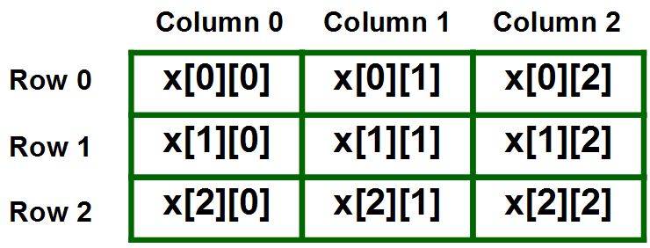](https://media.geeksforgeeks.org/wp-content/uploads/two-d.png)  
  
  
**Print 2D array in tabular format:**  
  
To output all the elements of a Two-Dimensional array, use nested for loops. For this two for loops are required, One to traverse the rows and another to traverse columns.  
  
**Example:**  
Java

class GFG {

public static void main(String[] args)

{

int[][] arr = { { 1, 2 }, { 3, 4 } };

for (int i = 0; i < 2; i++) {

for (int j = 0; j < 2; j++) {

System.out.print(arr[i][j] + " ");

}

System.out.println();

}

}

}

**Output:**

1 2

3 4